**Laravel Gates Policies Middleware And Guard**

**Middleware** runs of routes and also on controllers

Can be used to filter or inspect incoming requests

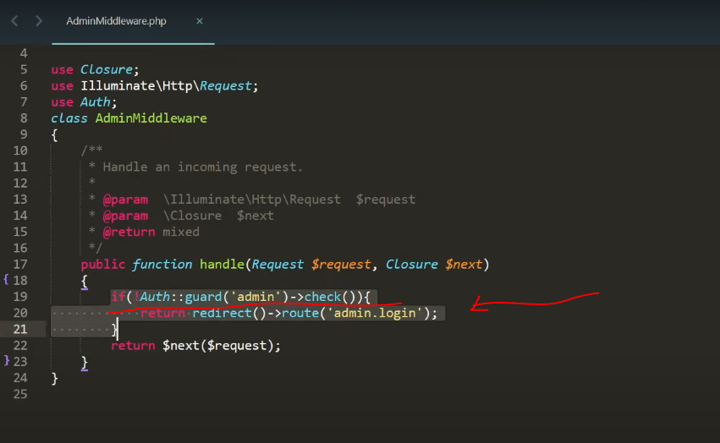

It is used to filter http requests

Laravel give by default auth middleware

User login ka bad login page visit na kra paya to laravel guest middleware data ha

Middeware ka andr filter kraga ka user login ka bad login page viist kr saktha ha ka nhi

Custom middle ware

Php artisan make:middleware AdminMiddleware

**Gates**: these are the functions defined in AuthSErviceProvider.php

After use loggedin what action he can perform

It is closure-based can be accessed any where in the project (from views, controllers, mode l… )

Konse user konse post ko edit kraga

Kahneen ese na ho ka ek user dosra ke post ko edit kr sakha, is chez ko filter out krna kaleya hum gates ko use kr sakhta han

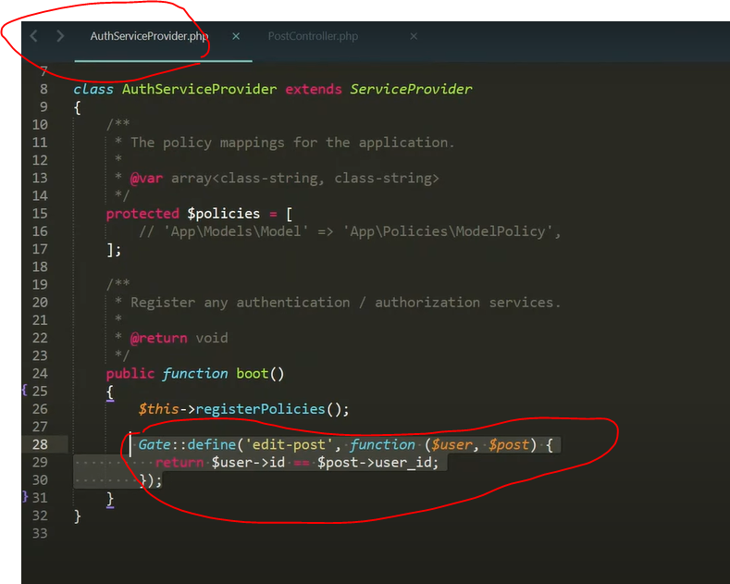

**Policies**

Class based

Authorization/permissions

Apply to a specific model and are stored in their own file

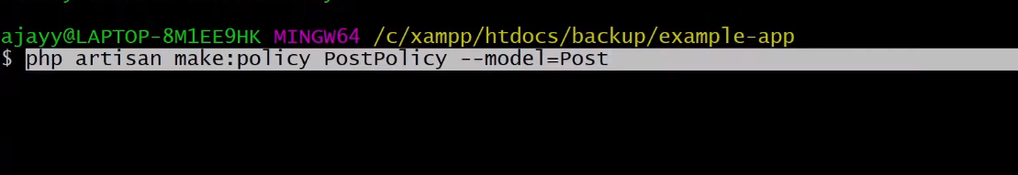

**Gurad**

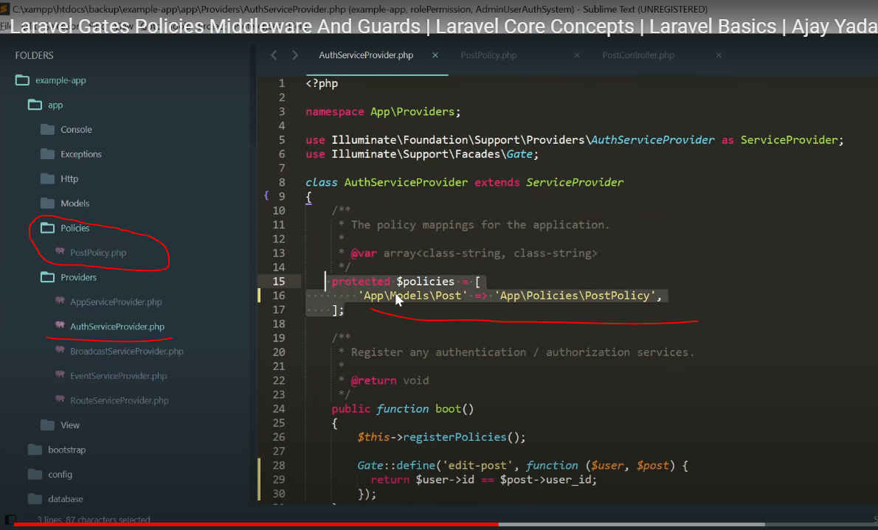

It login and register users

How will user login

What will be their session

All defined in guards

User ko login krna and authenticate krna

Laravel by defult web gurad use krta ha in config/auth.php

Laravel ka pore auth system gurad pa dependant ha

Jasa user gurd ka though authenticated hogya phir middleware filter kraga ka konse user konsa page dakhaga

You can filter these on view file like ya button admin ko show hoga ka nhi

**AdminUserAuthSystem**